Brno University of Technology

Faculty of Information Technology

Advanced Database Systems
2025/26


Rental Information System
(User Guide)

Eyobed Awel Nuri (xnuriey00)
San Kaung (xsanka00)
07/12/2025

Introduction
Welcome to the Rental Property Information System (IS). This application allows users to manage real estate inventory, visualize properties on an interactive map, and perform advanced searches using text, spatial location, and multimedia image analysis.

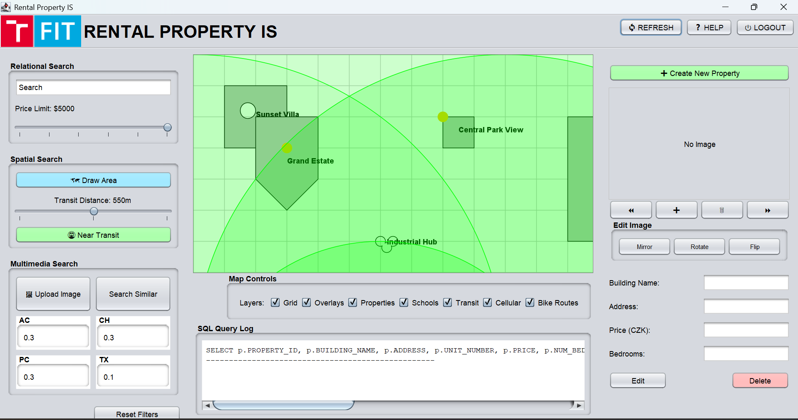

Top Menu Bar

Refresh: Reloads the application and resets the default setting.
Help: Opens the help documentation window.
Logout: Securely log out your account and return to the login screen.

Searching Methods (Left Panel)
Different kinds of search methods are located in left panel of the application.

Search Bar: Type keywords (e.g., Building Name, Address) into the text box.
Price Limit: Use the slider to set your minimum or maximum budget.
Spatial Search: To find properties based on geography and transit accessibility
Draw Area:
  - Click the Draw Area button.
  - Click on the map to define the corners of a search polygon (e.g., a specific neighborhood).
  - Double-click to close the shape. The system will search only within this boundary.
Transit Distance:
Adjust the slider to set the maximum walking distance (e.g., 550m) from public transport.
Near Transit Button:
Click Near Transit to execute the search. The map will display circular overlays indicating the transit zones

Multimedia Search
This advanced feature allows you to find properties that look similar to a reference photo. Click the “Upload Image” button to select a reference photo from your computer (e.g., a photo of a brick house). Then click the “Search Similar” button to find properties in the database that visually match your uploaded image.

Feature Weights (AC, CH, PC, TX): These fields allow you to prioritize how the image comparison algorithm works. You can adjust the decimal values (0.0 to 1.0) for:
AC / CH: Color-based matching (Auto-Correlogram / Color Histogram). Increase this if color is important.
TX: Texture-based matching. Increase this if building material (brick vs. glass) is important.
PC: Pattern/Structure matching.

Reset Filters
Clears all search criteria (Relational, Spatial, and Multimedia) and shows all properties.

Interactive Map (Center Panel)
All the schools, buildings, bus stops, bike roads, transit, and information that added by users are showing on the center of the windows.
Map control functions located below the map, use the Layers checkboxes to toggle specific data on or off to declutter the view:
- Grid: Shows/hides the background grid lines.
- Overlays: Toggles search shapes (polygons/circles).
- Properties: Toggles the display of rental buildings.
- Schools: Shows schools area which represent by red color.
- Transit: Shows transits which represent by yellow dots.
- Cellular: Shows cellular coverage area which represents by green circle.
- Bike Routes: Shows bike routes which are represented by green lines.

SQL Query Log: Located at the bottom center, this text box displays the actual SQL code that is sending to the database.

Property Management (Right Panel)

Creating a New Property
Click the green + Create New Property button at the top right. Then select the type of designs (Circle, Polygon, Line, Point, Multi Point, Multi Line, Multi Polygon) to draw in the map area.

Managing Images
Image Viewer: Displays the photo of the selected property.
Navigation: Use the << and >> buttons to scroll through multiple photos of the same building.
Add/Remove:
+ Button: Add a new photo to the property.
Trash Can Icon: Delete the current photo.
Edit Image Tools:
Mirror / Flip: Reflects the image horizontally or vertically.
Rotate: Rotates the image 90 degrees.

Manage Property Data
Create or update property information, Modify or add data in these fields
- Building Name: Enter the name of the complex (e.g., "Sunset Villa").
- Address: Enter the street address.
- Price (CZK): Enter the monthly rent in Czech Koruna.
- Bedrooms: Enter the number of rooms.
- Area: Enter the number of area.

Edit Button: Click Edit and modify the data then click SAVE for your changes to the database.

Delete Button: Click Delete to permanently remove the property from the database.

